RESUME

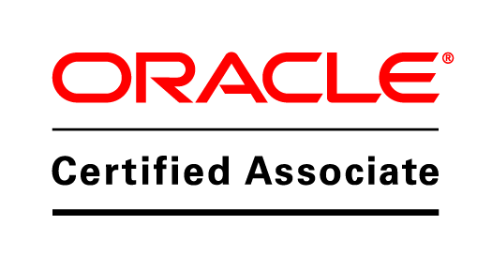

M-19/222,
Darshan Apartment,
Harshit Bhadiyadra Naranpura,
Mobile: 91-7623995806 Shastrinagar
Email: harshitmca2011@gmail.com Ahmedabad-380013

CAREER OBJECTIVE:

Seeking a challenging position at your Organization where I can utilize my educational and technical skills towards achieving organizational goals.

EDUCATIONAL QUALIFICATIONS:

Degree | Board/University | School/College | Passing Year | Percentage/Grade
MCA | Saurashtra University | Atmiya Institute of technology & Science, Rajkot | 2011 | 58.97
Certification Program In Banking, Insurance and Financial Management | Gujarat Low Society | Gujarat Low Society | 2007 | B+
B.com | Bhavnagar University | M.J.College of Commerce, Bhavnagar | 2005 | 69
H.S.C | G.H.S.E.B | R.K.Home School, Bhavnagar | 2002 | 64
S.S.C | G.S.E.B | R.K.Home School, Bhavnagar | 2000 | 73.43

CERTIFICATIONS:

Have cleared the certification exam of Oracle Database 10G SQL Expert and Oracle Database 10G PL/SQL conducted by Oracle University and acquire the OCA Certification.

TECHNICAL SKILLS:

Languages Known | SQL, PL/SQL,T-SQL
Database | Oracle 9i,10g, MS SQL Server 2012
Operating System | Windows
Other Tools | PL/SQL Dev, SQL Dev., Hora for Oracle Development.

PROFESSIONAL EXPERIENCE:
Project Title | Company Name | Roles & Responsibilities | Tools Applied | Duration
All Line Insurance System. (ALIS) | I-Engineering Software Pvt. Ltd, Ahmedabad | Responsible for analyzing and study client application and database and retrieve required data from the same to develop new system which is product based.  Having experience in Writing, Analyzing Stored Procedures, Exception Handling, Constraints ,Triggers, Index, Views, Cursors and Complex queries for business requirements.  Work with Data Migration Process as well. | SQL Server Management Studio-2012 | Oct, 2013 to Present

Project Title | Company Name | Roles & Responsibilities | Tools Applied | Duration
Core Banking Solution (Data Migration Project) | Acute Informatics Pvt. Ltd, Ahmedabad | Responsible for development of the database modules for the migration of data from the legacy sources to the identified strategic data platforms.  Expertise in writing jobs for extracting data from a global environment using SQL.  Experience in creation of different database objects. i.e Tables, Views, Procedures, Indexes, Synonyms, Exception Handling, Triggers, Packages.  Worked at client side at different regions of India. | Hora Version 9.0 for Oracle Development | July, 2012 to Sep,2013

Project Title | Company Name | Roles & Responsibilities | Tools Applied | Duration
SCROLL project of CMC Ltd. | CMC Limited, Ahmedabad | Developed SQL Query based reports as per the requirement of Election Department. | PL/SQL Developer v 8.0.3.1510 | Nov, 2011 to Jan, 2012.

PERSONAL DETAILS:

Gender | Male
Birth Date | 4th February,1985
Marital Status | Single
Languages Known | English, Hindi, Gujarati
Hobbies | Playing Chess, Surfing

DECLARATION:
I hereby declare that all the information given above is true to best of my knowledge and belief.
BHADIYADRA HARSHIT. H

